Multiple-choice section – choose the correct answer

Question 1 [1.1]

The solution to the equation 6(a – ) = 3(a + ) is:

A  B  C  D 

Question 2 [1.2]

The gradient of the line joining the points (, -3) and (, -2) is:

A  B  C  D 

Question 3 [1.2]

The gradient and y-intercept of the line with equation respectively are:

A  B  C  D 

Question 4 [1.3]

The equation of a linear graph with a y-intercept of  and a gradient of  is:

A  B  C  D 

Question 5 [1.4]

The line that is parallel to the line with equation  is:

A  B  C  D 

Question 6 [1.4]

The gradient of a line that is perpendicular to the line with equation  is:

A  B  C  D 

Question 7 [1.5]

Which of the following is not a solution of ?

A x =  B x =  C x =  D x = 0

Question 8 [1.6]

y = -2x + 6 and 2y + 6x = 7 have the solution:

A x = , y = -1 B x = -, y = 1 C x = , y = 11 D x = , y = 11

Multiple-choice results: ___ / 8

Short answer section

Question 9 11 marks [1.2]

Use words from the list below to complete the following sentences.

linear relationship ** perpendicular linear equation inequality one  
inverse operations gradient parallel rise over run y-intercept

(a) Lines that are __________________ have the same gradient.

(b) Lines that are ______________________________ meet each other at an angle of 90°.

(c) A _______________________________________ exists between two variables when the graph of the relationship is a straight line.

(d) A linear relationship is described by a _______________________________ .

(e) The general equation of a straight line is __________________ where  is the gradient of the line and  is the ________________________________ of the line.

(f) A linear equation has _____ solution and a linear _____________________ has a range of solutions according to the inequality.

(g) Linear equations can be solved by applying ______________________________ to both sides of the equation.

(h) The __________________________of a line is a measure of its steepness, which can be evaluated by evaluating the fraction _________________________.

Question 10 3 marks [1.1]

Solve the following equation.  


Question 11 4 marks [1.1]

Solve the following equation.



Question 12 2 marks [1.2]

Find the gradient of the line joining the points (3.9, 0.3) and (4.4, 9.8).

Question 13 2 marks [1.3]

Sketch the graph of the line with equation .

Question 14 4 marks [1.4]

(a) Show that the line with equation  is parallel to the line with equation .

(b) Show that the line with equation  is perpendicular to the line with equation .

Question 15 4 marks [1.5]

Solve each of the following inequalities.

(a) 3x – 1 ≥ -16 (b) -5x – 3 < 12

Question 16 3 marks [1.5]

Solve to find the set of x-values that satisfy 2(-3x + 4) ≥ 2x – 8.

Question 17 4 marks [1.6]

Solve this pair of simultaneous equations:

y = 2x + 3

4x – y = -2

Question 18 4 marks [1.6]

Solve this pair of simultaneous equations:

2x + 4y = 7

4x + 6y = 11

Short answer results: ___ / 41

Extended answer section

Question 19 7 marks [1.2, 1.3, 1.4]

An elevator is descending towards the basement of a building at a steady rate. It descends 4 metres every  seconds and it reaches the basement (h = 0) after 30 seconds.

(a) Sketch a graph that describes the relationship between the height h of the elevator at time t.

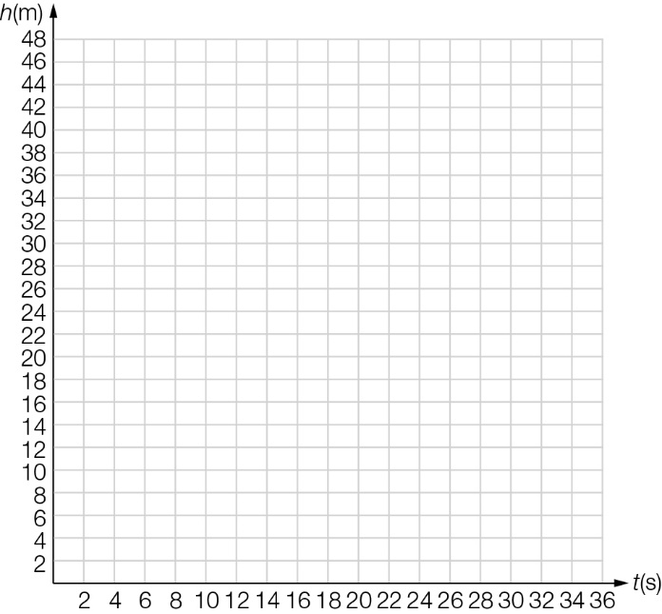

(b) Find the gradient of the graph and hence the rate of descent of the elevator.

(c) Write an equation that describes the relationship between h and t.

(d) How high is the elevator in the building when t = 0?

Question 20 10 marks [1.2, 1.3, 1.4]

(a) Sketch the line with equation  on the set of axes below.

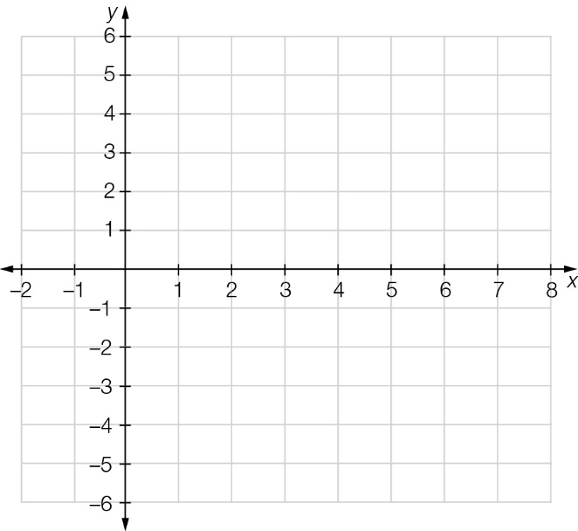

(b) (i) Draw the line AB that passes through the points A(2,0) and B(4,5) and find the equation of the line AB.

(ii) Prove that the line with equation  is parallel to the line AB.

(c) (i) Draw the line CD that passes through the points  and D(5,0) and find the equation of the line CD.

(ii) Prove that the line with equation  is perpendicular to the line CD.

Question 21 5 marks [1.6]

William, a hockey champion, is an expert serving in a sporting shop. Yesterday he sold two hockey sticks and three hockey bags for $473.98. This morning he sold one hockey stick and one hockey bag for $177.99. Find the cost of each hockey stick and bag.

Question 22 3 marks [1.1]

The sum of five consecutive odd numbers is 585. Find the numbers

Question 23 6 marks [1.1, 1.6]

A test with a total of 100 marks consists of 30 questions, some of which are worth 3 marks and the rest are worth 4 marks. Let x represent the number of 3-mark questions and y represent the number of 4-mark questions.

(a) Write two equations to represent this information.

(b) Solve these equations to find the number of each type of question.

(c) A different test has questions worth 2 marks and 3 marks. If the test is to have a total of 30 marks, write a list of the combinations of possible questions.

Question 24 9 marks [1.5]

(a) If a triangle has a base of 10 cm, will the sum of the other two sides be greater or less than 10?

(b) Consider the triangle shown. Write three inequalities based on the sum of the ‘other two’ sides.

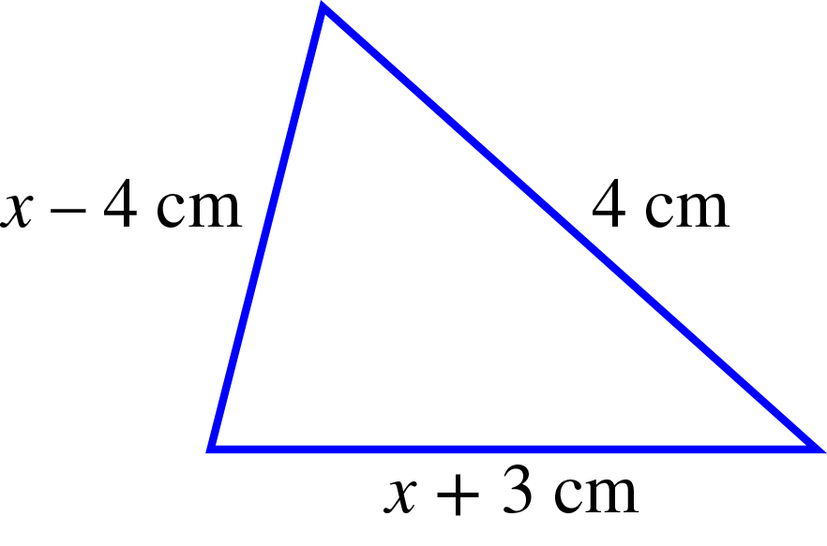

(c) Solve each of these inequalities.

(d) What do these results tell you about the triangle?

(e) Now consider the following triangle. Does this define a particular triangle? Solve inequalities to help you answer this question.

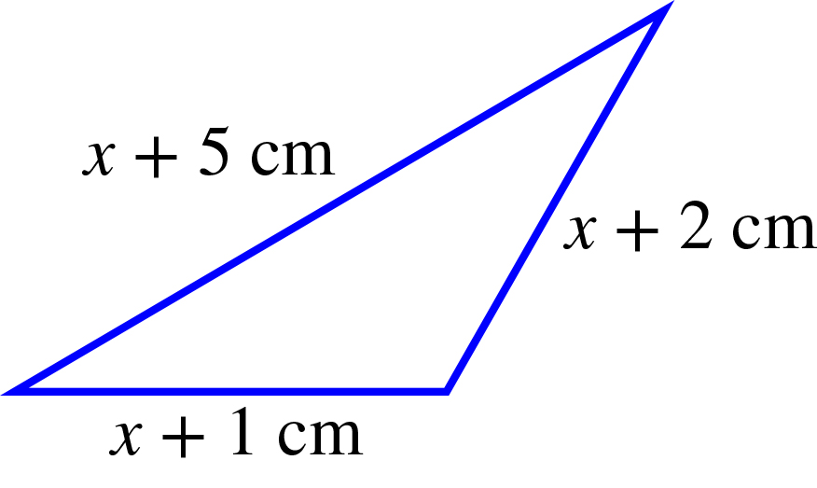

(f) Given the additional information that the shortest side is 5 cm, find the dimensions of the particular triangle that this represents.

Extended answer results: ___ / 40

TOTAL test results: ___ / 89